Session 9
- CREATE TABLE IF NOT EXISTS Orders ( order_id INT AUTO_INCREMENT PRIMARY KEY, customer_name VARCHAR(100), product VARCHAR(100), amount DECIMAL(10,2), order_date DATETIME DEFAULT NOW() );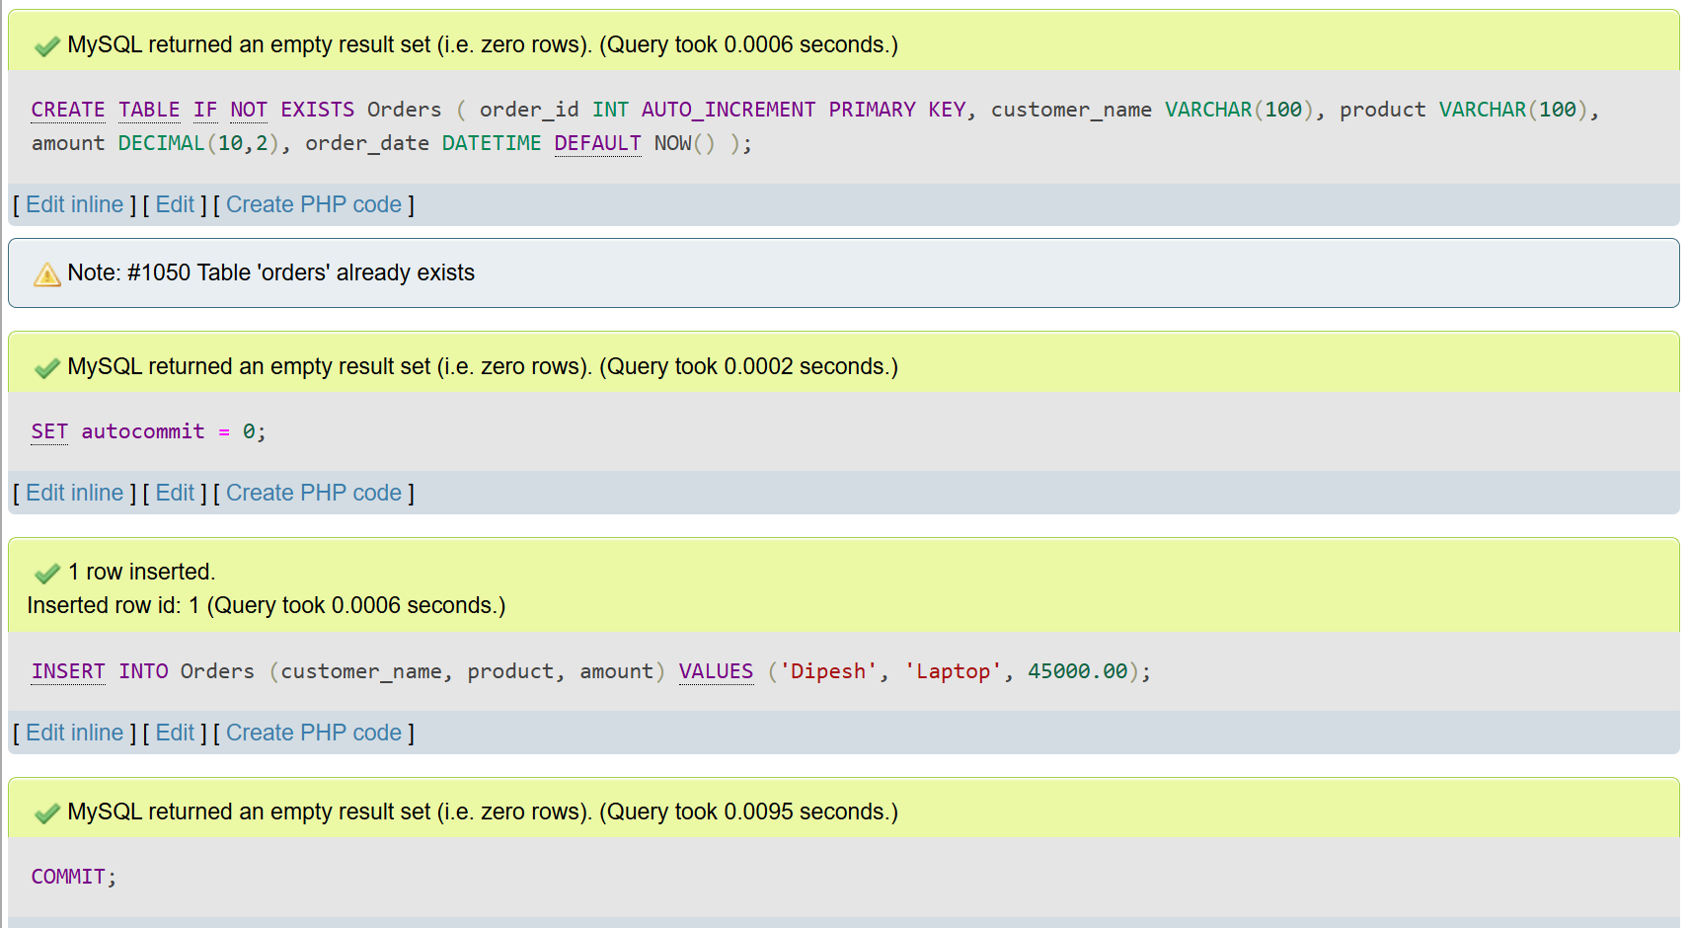

- SET autocommit = 0;
START TRANSACTION;
INSERT INTO OrderItems (order_id, item_name, quantity, price)
VALUES (101, 'Paneer Butter Masala', 1, 280.00);
INSERT INTO OrderItems (order_id, item_name, quantity, price)
VALUES (101, 'Garlic Naan', 2, 60.00);

ROLLBACK;

SELECT * FROM OrderItems;

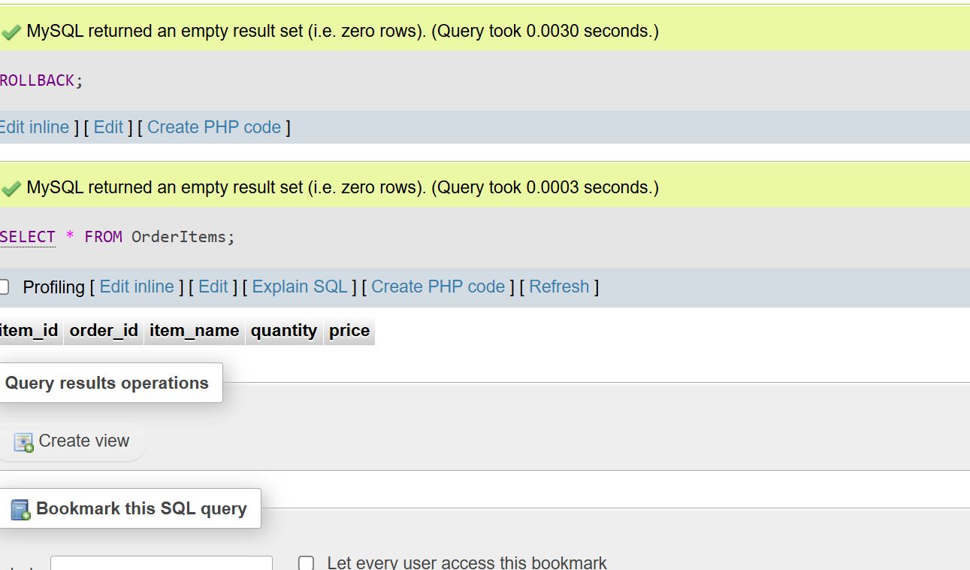

CREATE TABLE IF NOT EXISTS Cart ( cart_id INT AUTO_INCREMENT PRIMARY KEY, user_id INT, product VARCHAR(100), price DECIMAL(10,2) );
SET autocommit = 0;
START TRANSACTION;
INSERT INTO Cart (user_id, product, price) VALUES (1, 'iPhone 15', 79999.00);
SAVEPOINT after_first_product;
INSERT INTO Cart (user_id, product, price) VALUES (1, 'AirPods Pro', 24999.00);
ROLLBACK TO SAVEPOINT after_first_product;
COMMIT;
SELECT * FROM Cart;
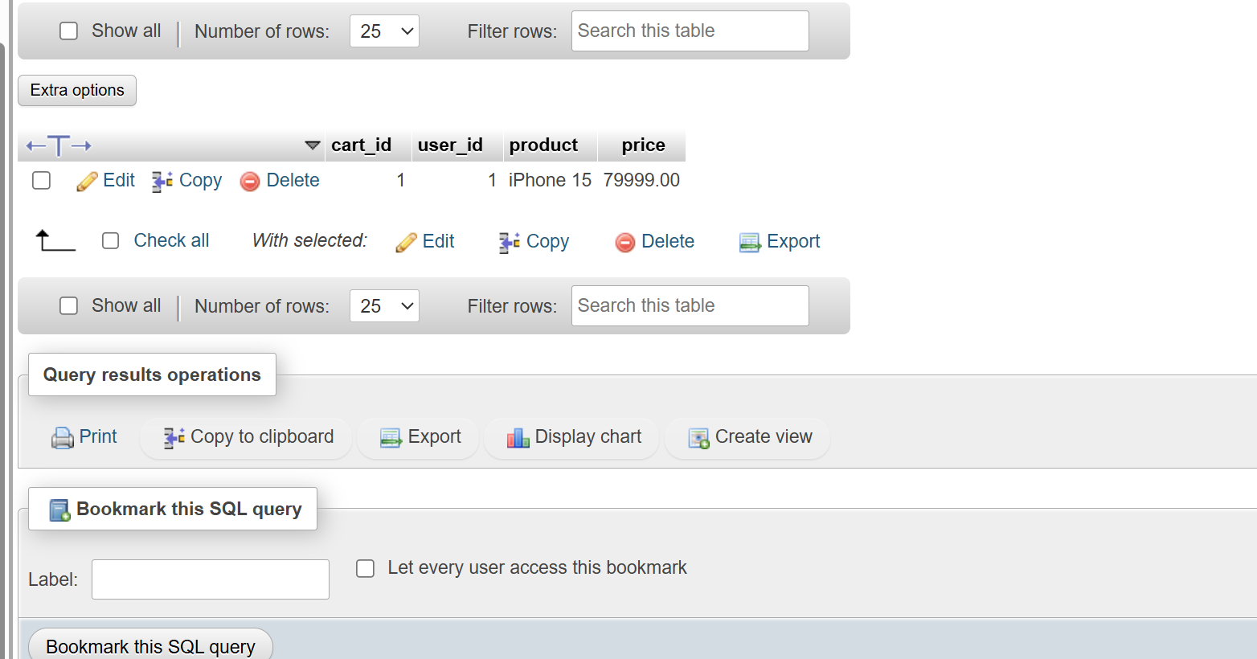

- 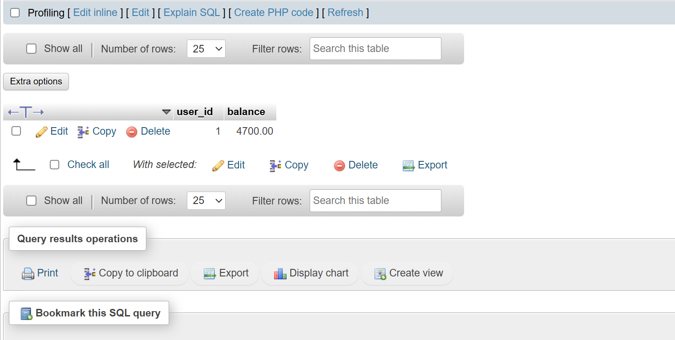

- CREATE TRIGGER trg_fixed_wallet AFTER INSERT ON Transactions FOR EACH ROW BEGIN UPDATE Wallet SET balance = balance - NEW.amount WHERE user_id = NEW.user_id; END;
